**KABOJJA JUNIOR SCHOOL**

**P.1 ENGLISH MID – TERM EXAMS I, 2024**

**Time Allowed: 2hrs 30 minutes**

**NAME**: ……………………………………………………………………………………………………………………….

**DISTRICT:** …………………………………………………… **CLASS:** ……………………………………….

1. **Write these words correctly**.

nerclea _________________ ookc ___________________

chertea _________________ tronma _________________

j03433492. **Who is this?**

This is a _____________________________________

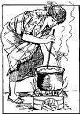

This is a _____________________________________

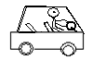

This is a ____________________________________

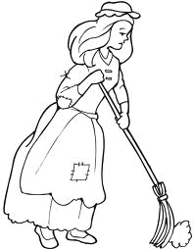

This is a ____________________________________

cleaner, cook, teacher, driver

3. **Circle the odd man out.**

a. bus, car, driver

b. pencil, book, building

c. teacher, cup, bursar

d. toilet, kitchen, book

4. **Write in small letters**.

A ___________________ D ________________

R ___________________ U ________________

K ___________________

5. **Fill in the missing letters**.

a, _______, c, ______, e , _______, g , ______,l

6. **Change in capital letters**.

broom _______________ chalk __________________

pen _________________ desk ___________________

tree ________________

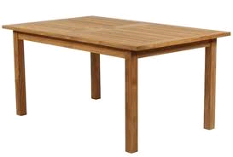7. **What is that?**

That is a _______________________________

That is a ______________________________

That is a ______________________________

8. **Match to plurals.**

bag books

table pens

book trees

pen bags

tree tables

9. **Make sentences using That is a ________________**

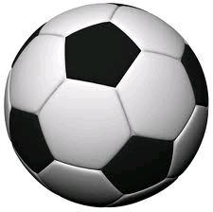

That is a ____________________________________

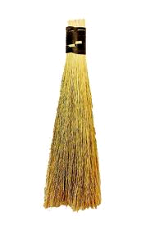

That is a ____________________________________

That is a ___________________________________

That is a __________________________________

That is a ___________________________________

chair, book, ball, broom, pencil

10. **Name these pictures.**

________________ _________________

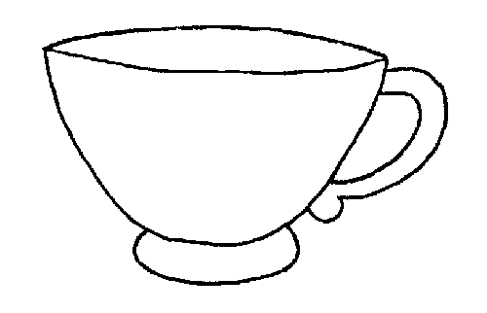

______________ _________________

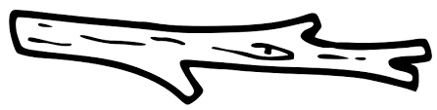______________

11. **Read the story and answer the questions.**

**A school**

At our school, we find teachers, bursars, cleaners, head teacher and matron. A teacher teaches us well and we use brooms for sweeping. I love my school.

**Questions.**

a. A ________________is a place where people go to learn.

b. We find ____________and ____________at school.

c. Draw your school.

d. A _______________is used for sweeping.